Press release
October 2019

Weinor GmbH & Co. KG
Not participating in R+T 2021

Sun and weather protection manufacturer weinor will not be taking part in the R+T trade fair in Stuttgart in 2021. The company wants to take other measures to intensify the partnership with its retailers and partners instead.
weinor, the manufacturer of awnings, patio roofs and Glasoasen, has decided not to present at R+T 2021. The company had a stand at R+T in 2018 after suspending participation in 2015. Even before the last trade fair, weinor Managing Director Thilo Weiermann had pointed out that participation in R+T did not go without saying but is evaluated from time to time.

"The right decision"
This evaluation has now been completed and led to the cancellation. Thilo Weiermann explains: "We discussed whether weinor would participate in the upcoming R+T for a long time. Now we have come to the conclusion that we want to pursue other paths to inform our retailers and partners about new products and intensify our partnership with them in 2021. What exactly they will be is being planned at the moment. But we're sure it's the right decision for us for 2021."

Trade fair included in decision-making process
weinor marketing manager Sylvia Hendel emphasises that this step was not easy and was only taken after intensive dialogue with the trade fair organisers. "We had a collaborative relationship with the R+T organisers during the talks at all times and will certainly go and take a look at Stuttgart with a tear in our eye in 2021."

Media contact:
Christian Pätz
Weinor GmbH & Co. KG || Mathias-Brüggen-Str. 110 || 50829 Cologne
Email: cpaetz@weinor.de || www.weinor.de
Tel.: 0221 / 597 09 265 || Fax: 0221/ 595 11 89

This text as well as high-resolution images and other information are available at°www.weinor.de/presse/.

Image material:

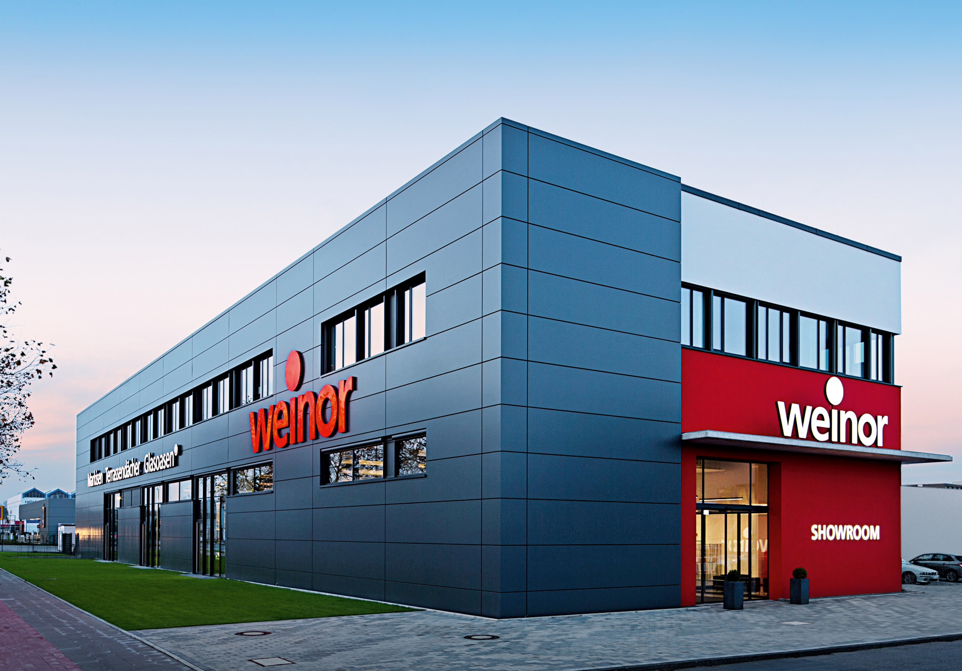

Image 1:
weinor will not be taking part in the R+T trade fair in Stuttgart in 2021.

Photo: weinor

