Press release
January 2021

Pergola awning plus vertical awning from weinor
Reliable all-round protection

The Plaza Viva pergola awning from the manufacturer weinor can now also be supplemented with the VertiTex II vertical awning. This means that two tried and trusted products from the sun and weather protection expert can now be combined.

Vertical shading on a pergola awning or patio roof offers the user numerous advantages. It prevents glare from the low lying sun, reduces heat build-up under the sun protection, keeps out the wind and protects privacy. The latter is an important criterion, especially for typical terraced houses built close together. To enable specialist companies to offer their customers more benefits, the Plaza Viva pergola awning from weinor can now be fitted with the VertiTex II vertical awning. As a result, two tried and trusted weinor products are combined into one reliable overall system.

Technically and visually coordinated
The Plaza Viva pergola awning is a weather all-rounder in a slim design, VertiTex II has a compact cassette and provides elegant vertical privacy and sun protection. Both systems interact visually to create a seamless look. With VertiTex II, the building owner can choose between a round or square cassette shape, to suit their taste. The vertical awning is attached to the Plaza Viva by a locking bar. This type of installation is safe and easy to carry out. Large pergola widths of up to six metres as well multi-section units are also possible in conjunction with the vertical awning.

Wind-resistant and convenient
In terms of fabric guiding, there are two versions of both awnings. VertiTex II is available with rail or zip technique, Plaza Viva as stretch (stretched on two sides) or OptiStretch (stretched on four sides) version. The combined construction is wind-resistant up to wind force 5 and can be controlled using weinor's BiConnect radio technology or by cable. Another bonus: numerous options are available to attach the VertiTex II to the Plaza Viva. For example, the vertical awning can be mounted all round, at the front and on each side or just on the side. There are almost no limits to the possible combinations.

Media contact:
Christian Pätz
weinor GmbH & Co. KG || Mathias-Brüggen-Str. 110 || 50829 Cologne
Email: cpaetz@weinor.de || www.weinor.de
Tel.: +49 221 / 597 09 265

This text as well as high-resolution images and other information are available at www.weinor.de/presse/.

Image material:

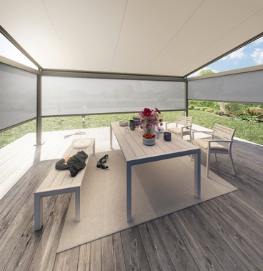
Image 1:
The combination of the Plaza Viva pergola awning with the VertiTex II vertical awning
offers an all-round package in terms of sun protection, privacy, glare protection and wind protection.

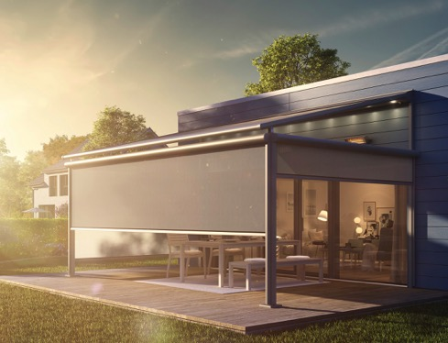
Image 2:
Visually the connection of both systems creates a seamless look.

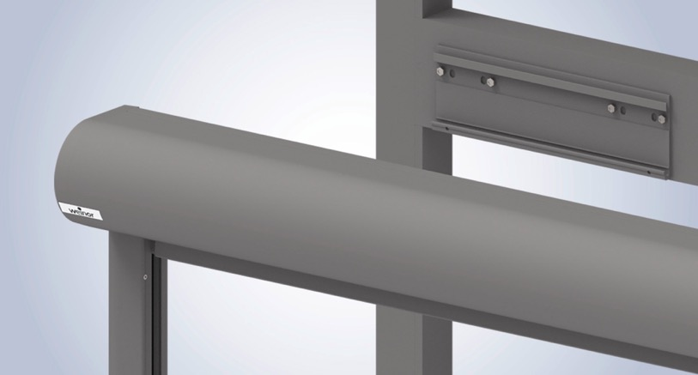
Image 3:
The locking bar assembly on the Plaza Viva is quick and easy for the fitter. Once the pergola awning has been erected, the locking bar is simply attached all the way round and then the VertiTex II is mounted on top.

Photos: Weinor GmbH & Co. KG

