Press release

Coloured RGB LED light stripe from weinor
Colourful times on the patio

The patio can be bathed in coloured light with the new LED stripe from the manufacturer weinor. The RGB light stripe can be fitted almost anywhere on the patio and later on too. The lighting can even be dimmed using the new BiEasy 15M Go! hand transmitter.

Patios and balconies are increasingly becoming design objects with which builder-owners want to express their personal taste. One important component in this is lighting. Cleverly integrated and intelligently controlled it contributes to creating a unique atmosphere outdoors.

48 shades produce a cosy mood
The new RGB LED light stripe offers balcony and patio users an extremely wide range of options for this. As there is a choice of up to 48 warm colours and 3 whites that produce a pleasant even light with the help of a diffuser. With its slimline, square design and small format the LED stripe adapts perfectly to the needs of modern design. It can be inconspicuously screwed on and designed in the same colour as the whole sun and weather protection construction, regardless of whether it's from weinor or another manufacturer.

Control and dim everything with one hand transmitter
The specially developed RGB radio control is accommodated well protected in the compact light bar housing. This allows for a direct power connection. A whole range of functions can be selected when combined with the BiConnect control from weinor. For example, the colours in 48 levels can be conveniently adjusted with the new easy to use BiEasy 15M Go! hand transmitter. The light can also be dimmed and all other weinor products, such as the sunscreen or heating, can be operated using the BiEasy 15M Go!

Ready-to-connect, flexible installation
The new LED stripe is for universal use. It can be fitted to almost any house wall and patio roof. The RGB stripe is also compatible with the weinor w17 easy full glass sliding door, the w26-c utility slide-and-turn partition and weinor PergoTex II pergola awning. The LED stripe is suitable for any assembly base thanks to the concealed bolting inside the housing. The cable outlet can be flexibly adapted to the structural conditions on site, whether it's on the left or right, at the top, on the side or to the rear.

Media contact:
Christian Pätz
Weinor GmbH & Co. KG || Mathias-Brüggen-Str. 110 || 50829 Cologne
Email: cpaetz@Weinor.de || www.weinor.de
Phone: 0221 / 597 09 265 || Fax: 0221/ 595 11 89

This text as well as high-resolution images and other information are available at°www.weinor.de/presse/.

Image material:

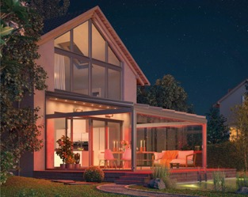
Image 1:
With the RGB LED light stripe from weinor there is a choice of up to 48 warm colours and 3 whites.

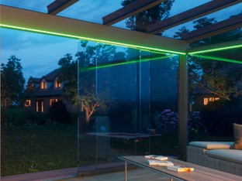
Image 2:
Slimline square and small: the RGB LED light stripe impresses due to its modern design.

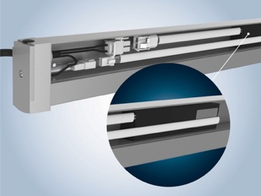
Image 3:
The RGB radio control sits protected in the compact light bar housing.

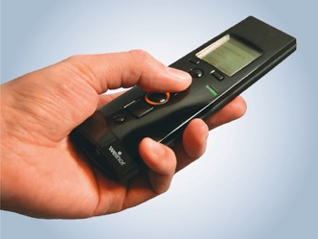
Image 4:
All weinor products can be controlled and the lighting can be dimmed using the new BiEasy 15M Go! hand transmitter.

Photos: weinor GmbH & Co. KG

