Press release

Cool Places. Hot Spots.
weinor at Intergastra

weinor presented its sun and weather protection products at the Intergastra hotel and gastronomy business trade fair in Stuttgart for the first time. The presentation met with great interest among the trade visitors. Awnings with large spans and modular systems such as the weinor PergoTex II with VertiTex II and UBE w17 easy were primarily in high demand. In addition to the stand in the exhibition hall, the weinor outdoor bar in the exhibition centre‘s inner courtyard also developed into a real magnet for visitors.

Media contact:
Christian Pätz
Weinor GmbH & Co. KG || Mathias-Brüggen-Str. 110 || 50829 Cologne
Email: cpaetz@Weinor.de || www.weinor.de
Phone: 0221 / 597 09 265 || Fax: 0221/ 595 11 89

This text as well as high-resolution images and other information are available at www.weinor.de/presse/.

Image material:

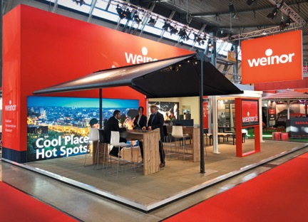
Image:
Exhibition highlight at the Intergastra: free-standing Duofix double awning, which can be dismantled again at the end of the season.

Photo: weinor GmbH & Co. KG

