Press release
February 2018

New VertiTex II vertical awning from weinor
Nice and small

The manufacturer weinor is presenting its vertical awning in a new visual and technical design. The VertiTex II impresses with the smallest cassette in both the round and square version as well as easier installation. With its unobtrusive and at the same time modern design it is ideal as general sun protection for the whole house.

Whether it's a patio roof, pergola awning, window, balcony or conservatory, thanks to its compact design, the many versions and versatile protection against prying eyes and the weather, the VertiTex is a real all-rounder. The clever, brilliantly designed solution offers protection from the dazzling sun, prevents the patio and indoors from becoming uncomfortably hot and shelters you from prying eyes. Thanks to the matching guide rails, new fixing techniques and the extremely small cassette shape, the VertiTex II can also be fitted, to difficult facade areas such as window niches or embrasures.

The smallest cassette – can be used anywhere
The new vertical awning impresses with an extremely small cassette even with large widths, and its numerous possible uses. Thanks to the patented weinor Opti-Flow-System that prevents the tube from deflecting under load. It ensures the fabric is ideally positioned and fabric widths of up to six metres can be achieved easily. The small roller tube for the VertiTex II has a floating bearing and yields when the fabric is wound up. The tube is therefore supported securely over the entire width of the awning, does not bow and the fabric is always ideally positioned.

Readily retrofittable
A cantilever housing fixation without bracket, just using guide rails, is possible with heights up to 2.5 metres, as a result of which the vertical awning can also be used in the smallest niches. The VertiTex II is therefore suitable for any installation situation and is extremely attractive as a product for replacement and retrofitting business. The vertical awning can also be controlled using the weinor BiConnect radio control, so just one hand transmitter is required for all products. A wired version is also available.

High wind stability and a variety of colours
Every facade or patio has its very own structural conditions in terms of appearance, location and construction. Which is why there is a selection of three different techniques to reliably guide the fabric. With the Zip and Rail version, the drop profile is pivoted and integrated into the guide rails using sliders. As a result, it is possible to safely extend and retract the vertical awning in strong winds too without the rails jamming. The Rope and Rail versions resist loads up to wind strength 5 (up to 10.8 m/s), the Zip version even up to wind strength 6 (up to 13.9 m/s). The privacy and sun protection therefore doesn't have to be retracted straight away, even in strong winds. When it comes to the colour, there is nothing left to be desired thanks to the large selection of fabrics. The VertiTex II has its own fabric collection, screens by weinor, which provides a large selection of high-quality fabrics in four different versions, including extremely hard-wearing fibreglass screens too. Depending on the fabric type, a constant exchange of air is guaranteed and rooms are prevented from overheating.

Improved installation and maintenance
VertiTex II also impresses with its simplified cassette fixing, where the cassette is mounted in the wall bracket and secured by the guide rails. From widths over 2.6 metres, the central bracket can be adjusted using a screw in order to compensate for the cassette bowing and installation tolerances. The cassette's side cover caps are flush and can be really easily closed using the button. The power cable can also be installed concealed behind these cover caps.
This ensures fast installation as no screwing is required.

Media contact:
Christian Pätz
Weinor GmbH & Co. KG || Mathias-Brüggen-Str. 110 || 50829 Cologne
Email: cpaetz@Weinor.de || www.weinor.de
Phone: 0221 / 597 09 265 || Fax: 0221/ 595 11 89

This text as well as high-resolution images and other information are available at°www.weinor.de/presse/.

Image material:

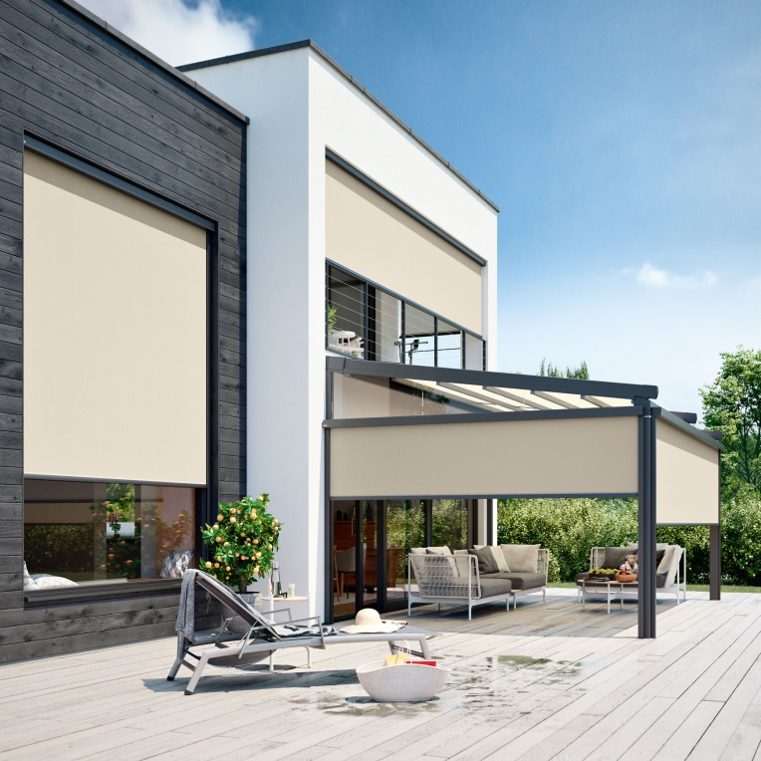
Image 1:
A harmonious overall look: VertiTex II can be used on windows, patio roofs, balconies and conservatories.

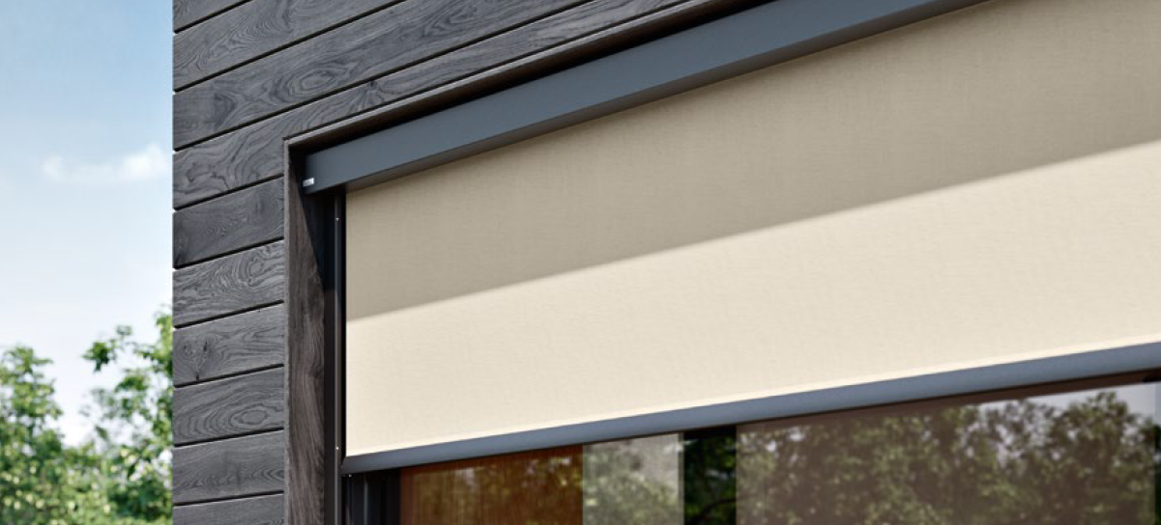
Image 2:
The VertiTex II is suitable for any installation situation, for example in
window niches or embrasures.

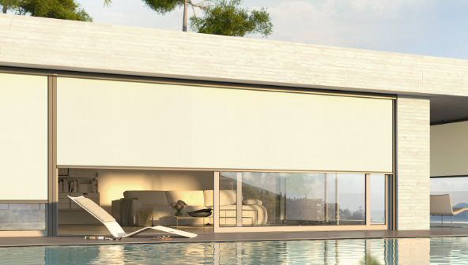
Image 3:
The smallest cassette: just 75 mm high! weinor manages fabric widths up to 6 metres with an extremely small awning cassette.

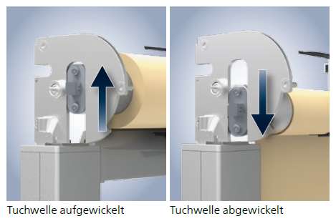
Image 4:
The Opti-Flow-System's roller tube has a floating bearing that ensures the fabric is perfectly positioned at all times.

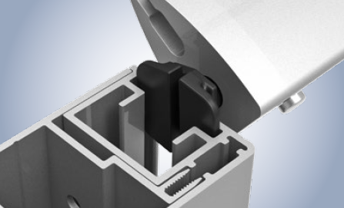
Image 5:
Securely guided even in winds: the Zip and Rail version's drop profile is pivoted and integrated into the guide rails using sliders.

Photos: weinor GmbH & Co. KG

