Press release
February 2018

Weinor´s new three-part fabric books “my collections” for awnings
Modern design, faster consultation
The manufacturer weinor is launching a new fabric collection for awnings on the market in February 2018. my collections consists of a variety of modern acrylic and polyester fabrics in three parts, which each appeal to different types of customers. With the focus on 143 spinneret dyed, colour fast patterns in total, weinor wants to make it easier for its retailers and partners to select the right fabric. The new collection books are designed as a modern consultation tool to easily and quickly close the sale.

"my collections is the result of a long and intensive development process. It was worth it though as we can now offer our customers a collection of great fabrics. The consultation can also be made much simpler and shorter with the new matching collection books," Manuel Kubitza, Creative Director at weinor, is pleased. His optimism is justifiable as the new awning fabric collection impresses due to its all-round coherent concept. Kubitza and his team invested more than two years in the preparation. They incorporated many different aspects while compiling the patterns: advice was sought from trend researchers, the fabric suppliers Parà and Sattler were consulted and workshops were organised with retailers and partners to choose the right selection. The result: a compact, manageable fabric collection with three colour focuses and modern, high-quality and colour fast fabrics.

The three pattern compositions: grey, beige and colour
With the momentum collection the name says it all, as the trend colour grey can be found in great variety here: with pinstripes, lines, fine and rough structures as well as block stripes. momentum is aimed at end customers who prefer a clear, timeless interior design and lifestyle. The mélange collection consists of harmonious beige and taupe shades. It is also aimed at buyers with a more modern design standard who favour a slightly more homely style. Things then get really colourful in the not crazy collection. It includes many creative colour trends and is designed for those who want to create exquisite interior design accents. All the fabrics are spinneret dyed, as before. This means the pigment is embedded into the fibres during the spinning process – a major advantage as the finished yarn is therefore fully saturated and the fabric keeps its brilliant colour for years to come.

Fabrics with wild silk structure
There are patterns with the same design elements in all three collections: block stripes, imaginative stripes and single colours. There are also wide block stripes with structured fabric areas in varying thickness, so-called "wrong block stripes" with different shades of a colour, as well as neutral and colourful pinstripes. Fabrics in wild silk structure also appear in every collection. They are innovative patterns with light lines. Their pleasant feel and woven threads in varying thickness, which give the fabric an exceptional surface, are typical of these.
Consultation-friendly collection books
The three-part collection books are extremely practical for everyday use in consultation and sales. "Many end customers want an awning fabric that matches their house facade and patio equipment in colour. By focusing on promising, strong patterns and a clear compilation in three parts, the specialist company can quickly guide customers to the shades that are worth considering," knows weinor Marketing Manager Sylvia Hendel. Another clever detail is the mounting technology for the three collection parts. They are held together by a magnet. So anyone who wants to show their customer just one collection part simply separates it from the others and reattaches it again later on. As a result, the pattern samples can also be held up to the light without any major effort to demonstrate the intensity of the shades. Stable carrying straps on the side make them much easier to transport. "During conversations with our retailers and partners, the request came up time and time again to design the collection books to make the consultation easier. This was the guiding principle during concept development," explains Manuel Kubitza.

"A consistent identity for a sensuous as well as technical product"
Besides the three collection books that turn into one using the magnets, weinor is also offering its customers a smaller half-sized compact collection, in which all 143 patterns are compiled. It includes all the patterns in the three colour categories in one book. my collections is available on the market for end customers from 1 February, weinor retailers and partners are receiving it beforehand though. The initial feedback is very positive. The weinor team is getting ready for great interest and strong demand. Creative Director Manuel Kubitza: "We have tried to give an understandable and consistent identity to an as it were sensuous as well as technical product. I think we have succeeded."

my collections from weinor: the facts
- One collection, three collection parts
- Easy to separate and reattach magnetic collection parts
- Spinneret dyeing to ensure colour fastness
- 143 fabric patterns compiled in a manageable collection
- Lightweight, easy to present with the light behind them as a result

Publisher:
Christian Pätz
weinor GmbH & Co. KG || Mathias-Brüggen-Str. 110 || 50829 Cologne
Email: cpaetz@weinor.de || www.weinor.de
Phone: 0221 / 597 09 265 || Fax: 0221/ 595 11 89

This text as well as high-resolution images and other information are available at°www.weinor.de/presse/.

Pictures:

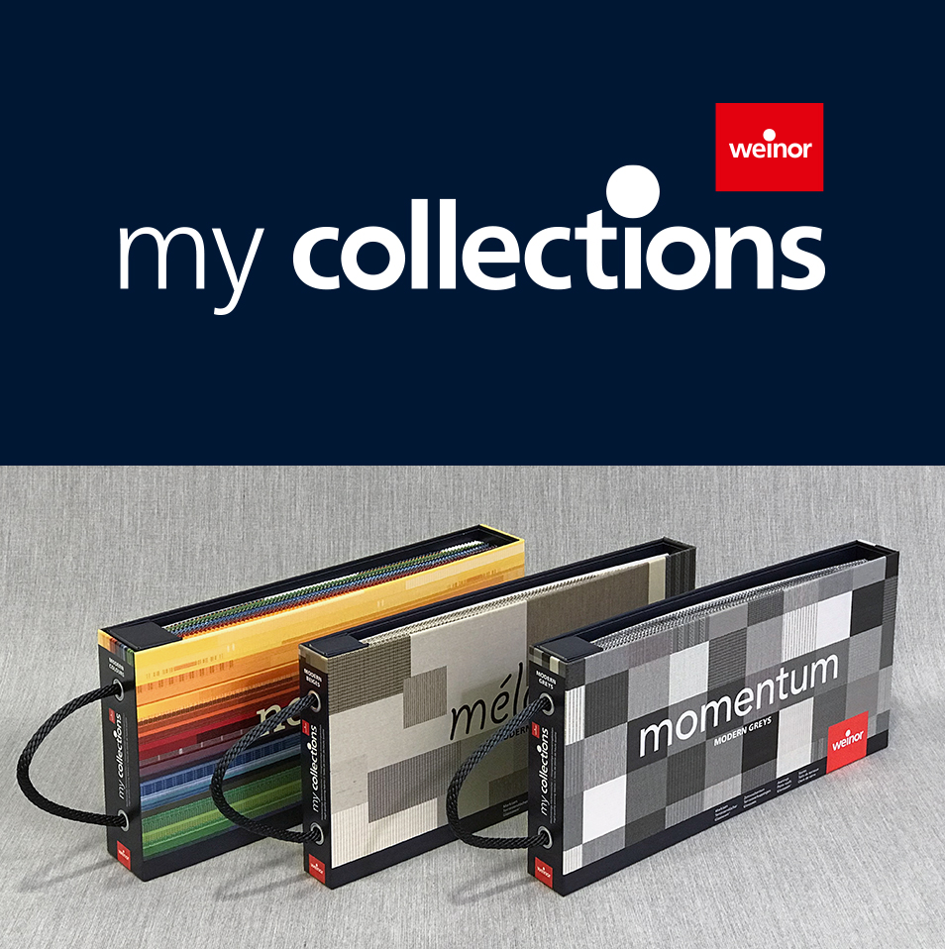
Image 1:
One collection, three parts: my collections from weinor consists of the momentum, mélange und not crazy collection parts.

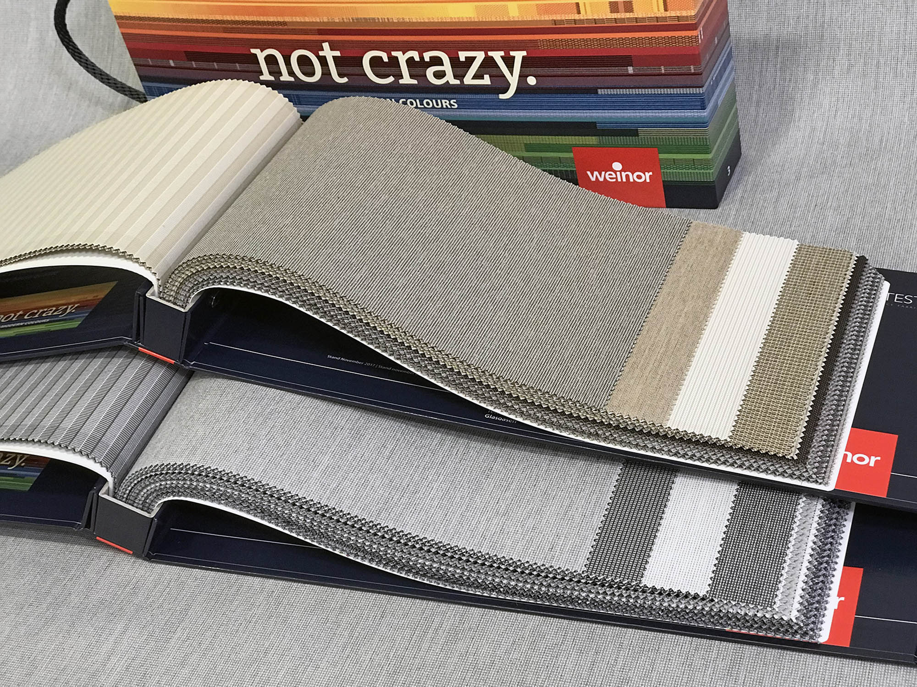
Image 2:
The collection books are clearly designed and compiled into three themed colour groups. This makes it easier to select the pattern.
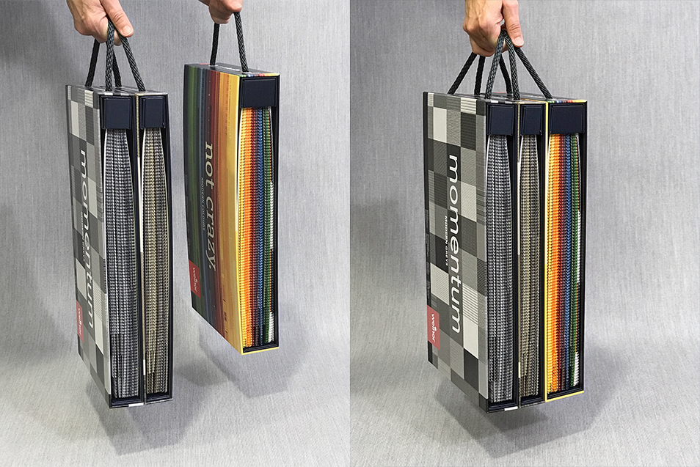
Image 3:
Handy: the collection parts can be easily separate from each other and reattached by magnets.

Image 4:
Whether it's grey, warm beige or creative colours: there is something to suit all tastes with the modern patterns in my collections.

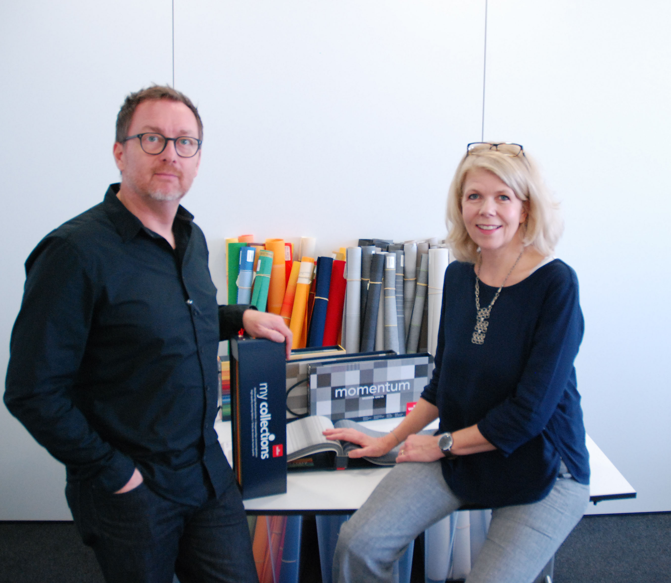
Image 5:
Intensive work – a successful result: weinor Marketing Manager Sylvia Hendel and Creative Director Manuel Kubitza present the new fabric collection.

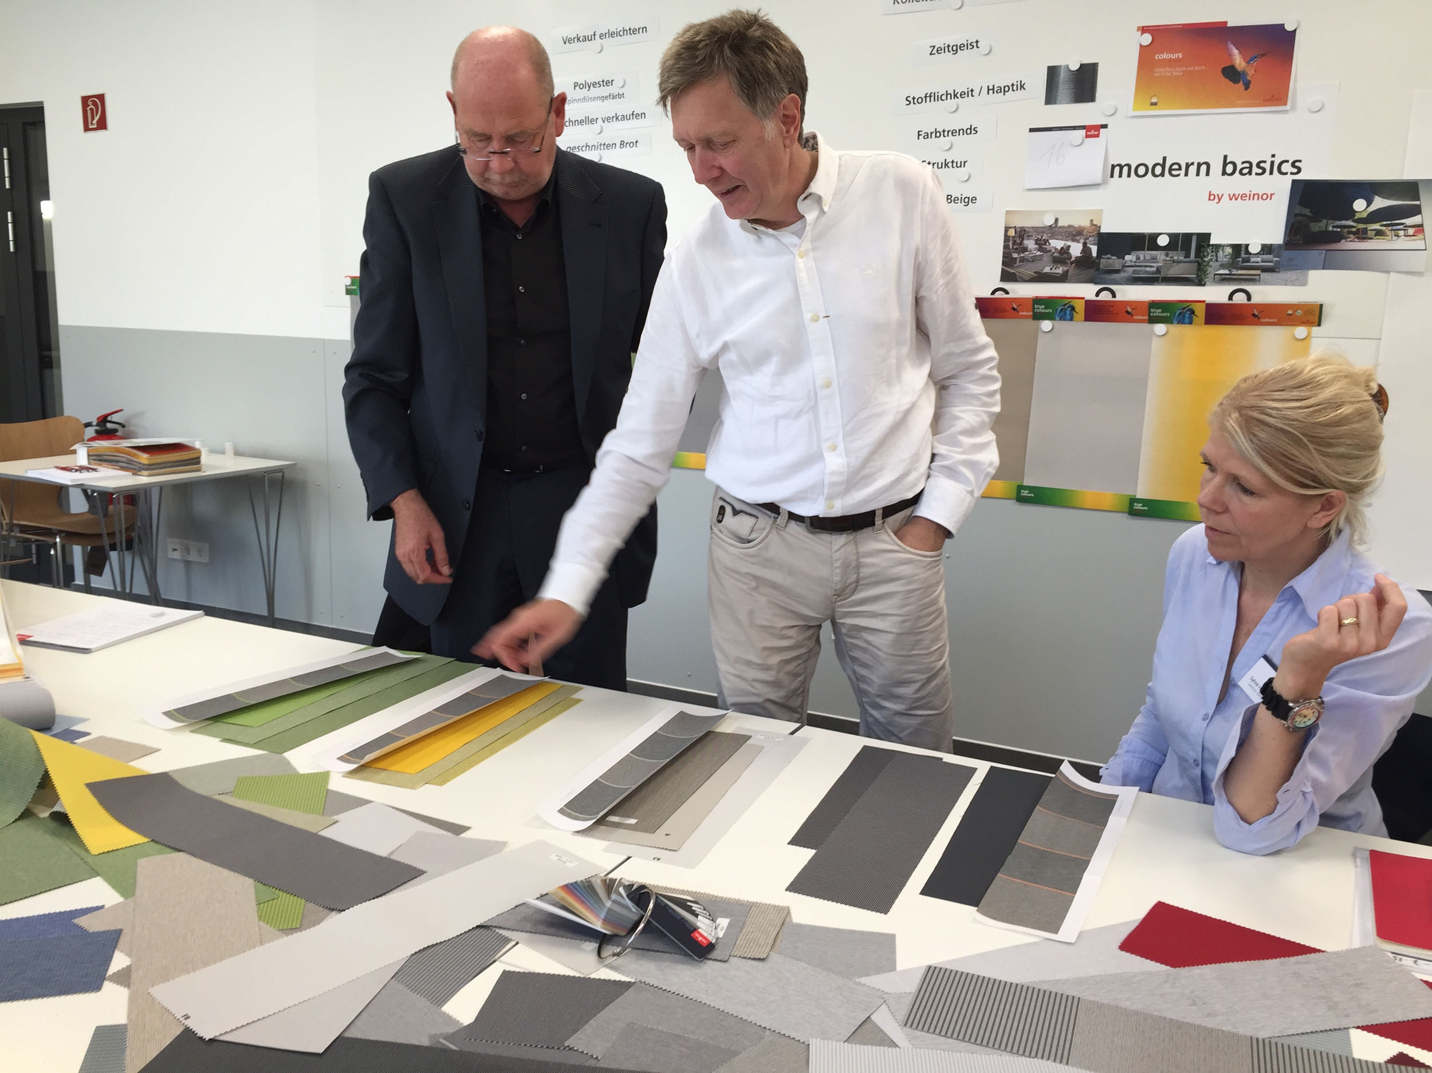
Image 6:
Close cooperation: weinor retailers and partners contributed their knowledge and creativity to the my collections awning fabric collection in workshops (on the right: weinor Marketing Manager Sylvia Hendel).

Photos: weinor GmbH & Co. KG

