Press release

Terrazza Pure glass patio roof from weinor
Cubically beautiful

The manufacturer weinor is launching a cubic patio roof on the market. The glass and aluminium construction impresses due to its modern appearance, high quality and variety of features.

Minimalist design is totally trendy when planning buildings. But this architectural style is becoming increasingly popular for patios too. Which is why weinor has now developed the Terrazza Pure cubic glass patio roof. The highlight is that the straight roof supports have fixed, supported glass supports that ensure the glass elements are integrated at an angle that is invisible from outside. Resulting in a cubic look and a system that allows reliable drainage from the roof at the same time. Another bonus: this design is extremely stable and can absorb high snow loads up to 550 kg.

Customised design with coloured lighting and decorative strips
Any builder-owners who want to give their weather protection a special personal touch, can equip the Terrazza Pure with lighting and decorative strips. The optional, high-quality coloured LED strips can be integrated into the roof support and posts. Besides three whites, 48 different colours in total can be adjusted and even dimmed using the weinor BiConnect control hand transmitter. Anyone who prefers variety, can set different colours for the roof supports and posts. There is even a programme where all colours can be run through automatically. Resulting in the patio roof being bathed in a different, unusual light time and time again. There are also five attractive anodised aluminium decorative strips available for the roof supports and posts, which give the Terrazza Pure an elegant look.

Integrated electronics and easy conversion into a Glasoase

Besides the visual highlights, Terrazza Pure also offers the fitter practical advantages. The new wall bracket profile provides space for the electronics and pre-equipped cable routes for all the required leads. This makes the electrical connections much easier. It is also simpler to extend it with glazing elements. As they can be easily fitted under the roof support and guttering without any angle of inclination thanks to the cubic shape. Another advantage of the straight design is that an appropriate head clearance height is even guaranteed with lower roof connection heights due to the design as there is no roof pitch.

High-quality and long-lasting
Terrazza Pure is statically tested and consists of a durable aluminium construction. Even the profile edges are powder coated in colour at weinor's own factories with strict quality checks. This guarantees the best protection against corrosion and weathering as well as colour fastness and a uniform gloss level. Only durable stainless steel screws offering maximum corrosion protection are used as standard.

Expected market launch in D, AT, NL, BE, LUX: mid-April 2018

Media contact:
Christian Pätz
Weinor GmbH & Co. KG || Mathias-Brüggen-Str. 110 || 50829 Cologne
Email: cpaetz@Weinor.de || www.weinor.de
Phone: 0221 / 597 09 265 || Fax: 0221/ 595 11 89

This text as well as high-resolution images and other information are available at°www.weinor.de/presse/.

Image material:

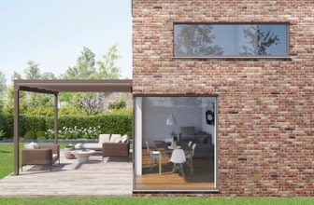
Image 1:
Terrazza Pure, the new glass patio roof from weinor, impresses with its cubic look.

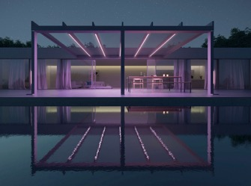
Image 2:
High-quality colour LED strips bathe the patio in a pleasant light of your choice.

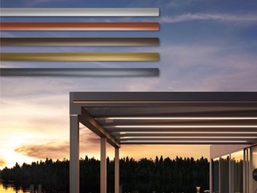
Image 3:
The posts and roof supports can accommodate anodised aluminium decorative strips, on request.

Photos: weinor GmbH & Co. KG

