Press release

Frank Rappholz: new weinor plant manager in Möckern / Eastern Germany

Frank Rappholz is taking over the management at weinor’s Möckern plant from January 2020. He is therefore replacing Lutz Wilke. Frank Rappholz has already held important positions involved in developing the production location in Möckern since 1992. Lutz Wilke, who has managed the plant since 1996 and worked on weinor’s management team for many years, is now retiring.

Media contact:
Christian Pätz
Weinor GmbH & Co. KG || Mathias-Brüggen-Str. 110 || 50829 Cologne
Email: cpaetz@Weinor.de || www.weinor.de
Phone: 0221 / 597 09 265 || Fax: 0221/ 595 11 89

This text as well as high-resolution images and other information are available at www.weinor.de/presse/.

Image material:

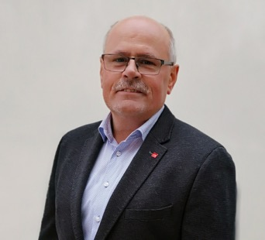
Image:
Frank Rappholz is the new plant manager of Weinor in Möckern.

Photo: weinor GmbH & Co. KG

