Press release

220 guttering for weinor Terrazza patio roof
Large spans without any middle posts
weinor now has new guttering in its range for its reliable Terrazza patio roof. It improves the statics of the whole patio roof as a result of its higher headroom. Larger widths are feasible and the gutters weigh less.

The Terrazza patio roof has successfully established itself on the market for more than 15 years. It is mainly distinguished by its high quality and sophisticated design. weinor is now supplementing the popular weather protection with another technical innovation, the 220 guttering.

Better statics – larger widths
The guttering is considerably more durable as its height is now 220 mm instead of 160 mm. Depending on the depth and snow load, up to 20% larger spans can be managed between the posts without reinforcing the guttering with steel. The benefit for patio users: larger roof widths are feasible without any middle posts so the view ahead is not restricted.

Less steel – lighter weight
Transport and installation is much easier with the 220 guttering. As large sizes are possible without or with much less steel thanks to the new channel concept. This eases the strain on the fitter's back. weinor has three design versions: without steel and with 140 mm or 180 mm high steel. The new weinor 220 guttering is now available for the Terrazza Originale and Plus versions in combination with the 115 post.

Easy installation, fast assembly, problem-free attachment
Glazing elements and the VertiTex II vertical sunshade can be really easily attached to the weinor patio roof with the 220 guttering. As a result, weinor retailers and partners have the possibility of offering their customers more benefits and profiting from extra business. Even the new VertiTex II vertical awning's Zip version can now be fitted onto the 220 guttering without too much effort. The guttering's adjacent components, for example the posts, can also be fitted just as easily as before. Another bonus: the guttering has a double bottom. So the attachments and glazing elements can simply be screwed on from underneath.

Expected market launch: April 2018

Media contact:
Christian Pätz
Weinor GmbH & Co. KG || Mathias-Brüggen-Str. 110 || 50829 Cologne
Email: cpaetz@Weinor.de || www.weinor.de
Phone: 0221 / 597 09 265 || Fax: 0221/ 595 11 89

This text as well as high-resolution images and other information are available at°www.weinor.de/presse/.

Image material:

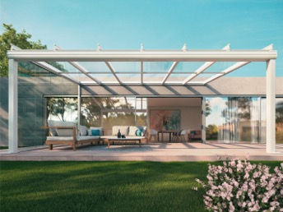
Image 1:
Larger widths can be managed thanks to the new 220 guttering for the weinor Terrazza patio roof.

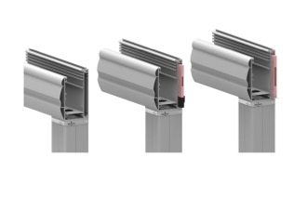
Image 2:
Three different versions: without steel and with 140 mm or 180 mm high steel. The 220 mm headroom allows for larger snow loads and lightweight guttering.

Photos: weinor GmbH & Co. KG

