Press release
September 2017

Plaza Viva from weinor
The weather all-rounder

The new Plaza Viva pergola awning offers reliable protection from the elements. It is wind-resistant and rainproof. A three-part rain protection system guarantees that rain water is reliably drained off and there is far less stress on the awning construction and fixings.

Many end users – commercially and domestically - don't just want pure sun protection for their valuable outdoor space but also want to make the most of being outdoors during short rain showers without getting wet! weinor is now filling this gap with Plaza Viva. The new pergola awning stands out due to many technical innovations that give the end customer a clear benefit and make installation easier.

Clever rain protection thanks to the three-part system
A minimum pitch is required with awnings to ensure that rainwater drains off reliably. With Plaza Viva, rain water can be safely drained off from a pitch of only 4 degrees – thanks to the additional of an adjustable telescopic post. By simply using a gear handle it can be lowered to achieve the necessary pitch. The wall bracket has floating bearings so that the construction is relieved during the downwards movement and remains inherently stable. A compensation joint on the post in the transition to the side channel achieves the same effect. Both guarantee that the pitch of the entire awning is ideally adjusted.

Reliable tension system, wind stability and quicker installation
There is now a new tear resistant rope for the tried and tested weinor tension system. It operates up quietly thanks to its flat design. The Plaza Viva's wind stability up to wind force 6 is produced by a new solid side channel. Reinforcement is not necessary and it can be fitted quicker as a result. Installation is also made easier due to a service opening in the cassette. It offers easy access to the drive and control, which guarantees much faster installation.

Attractive options
Plaza Viva is now also available in an OptiStretch version. The fabric is guided securely in the side channel in the process. This provides even higher wind stability and more rain protection. The fabric sag is also reduced and there are no overhanging edges on the sides. The optional LED lighting is integrated unobtrusively into the cassette and provides a pleasant, warm white light. Plaza Viva can also be fitted with a crank operated Valance Plus, which provides reliable privacy and glare protection even with a low-lying sun.
Immaculate look
Plaza Viva is designed so that almost all fixings are invisible from the outside. As a result, the awning design looks slimline, modern and elegant. Over 150 fabric designs and more than 200 frame colours give the end user the option of designing the awning to their taste and to match their house façade and style.

Plaza Viva: technical data
Max. width: 6 m
Max. projection: 5 m
Multi-unit systems: optional
Wind protection: tested up to wind force 6 (Beaufort scale)
Rain protection: from 4° pitch
Roof pitch: 4° - 25°
Mounting alternatives: installation on walls, ceilings and roofs
Motor drive: as standard

Media contact:
Christian Pätz
weinor GmbH & Co. KG || Mathias-Brüggen-Str. 110 || 50829 Cologne
Email: cpaetz@weinor.de || www.weinor.de
Phone: 0221 / 597 09 265 || Fax: 0221/ 595 11 89

Image material:

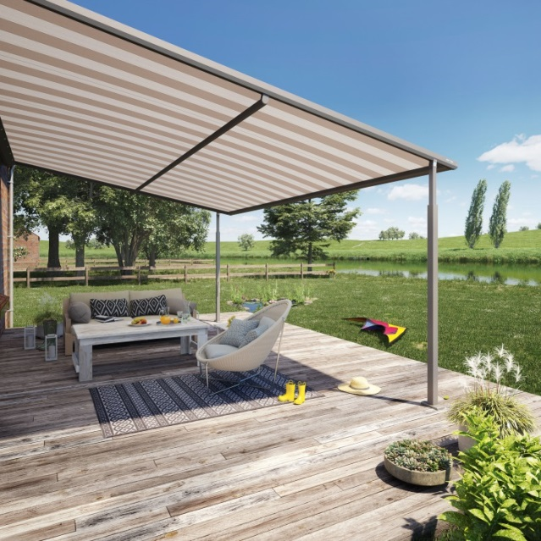
Image 1:
The new Plaza Viva pergola awning from weinor offers reliable weather protection.

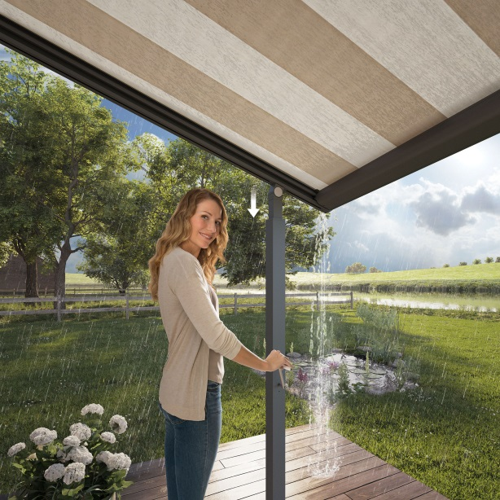
Image 2:
The awning can be lowered using the optional telescopic post to reliable drain off rainwater.

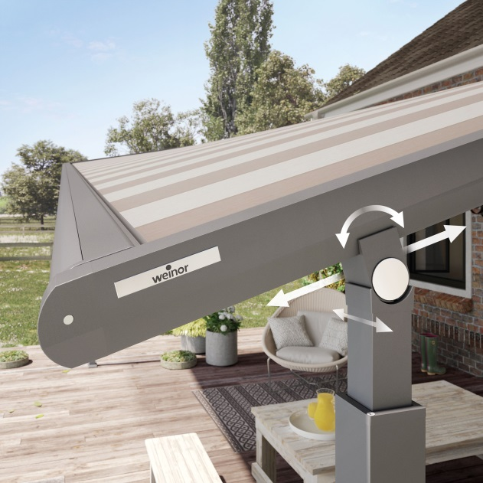
Image 3:
A compensation joint relieves the construction when the post is lowered.

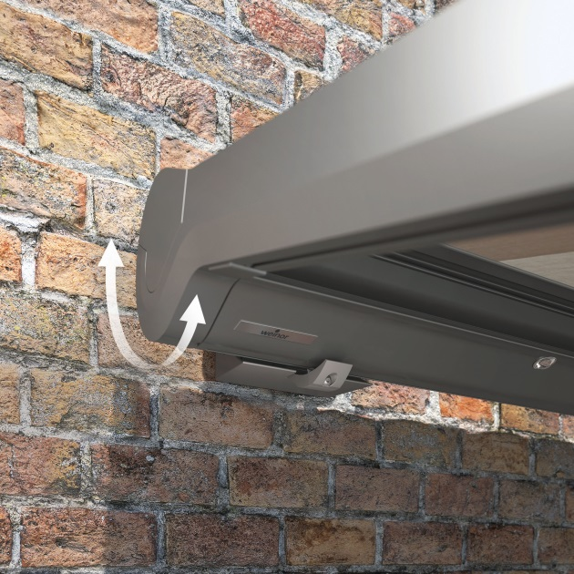
Image 4:
The wall bracket with floating bearings also ensures that the awning construction is relieved during the downwards movement.

Photos: weinor GmbH & Co. KG

